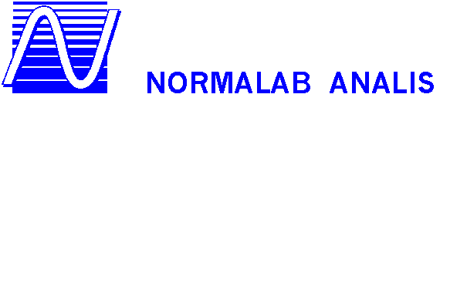
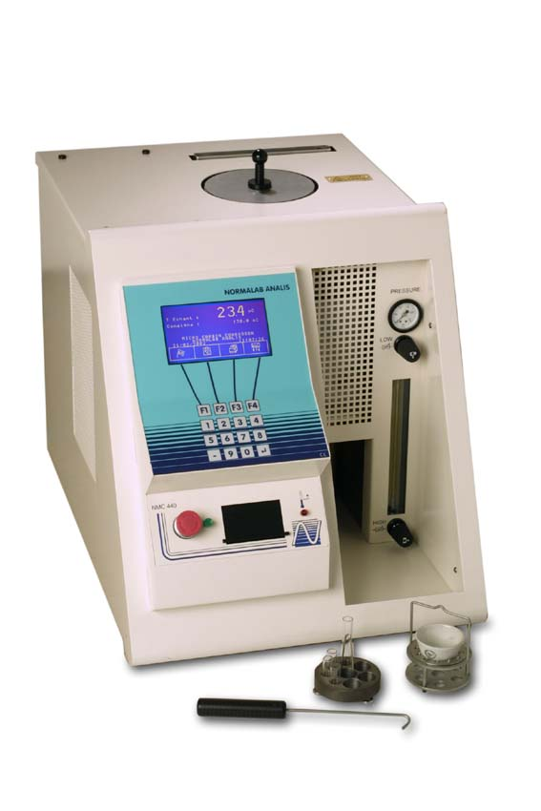
MICRO CONRADSON RESIDUE &
ASH TESTER
MICRO CONRADSON

MODEL NMC 440
NEW GENERATION OF THE FULLY AUTOMATED MICRO CONRADSON :

 A manometer located in front of the instrument displays the admitted pressure and a flow meter, the gas flow in the oven. Each solenoid valve can be either manually or automatically activated.

 The detailed test reports can be printed out in 40 or 80 columns at choice, or read on the display screen.
Initial and final weights can be added to tests reports and the carbon residue will automatically be calculated at the end of the test.

 The NMC 440 is delivered with 3 different holders to perform above mentioned standard methods.
 Instrument provides a front access to a condensing pot for an easy cleaning of all ducts between the oven, the pot and the chimney using the supplied accessory.
 The instrument is equipped with a RS232 connection for data transfer to a supervisor or a LIMS system. In addition, the ticket printer ( delivered with the apparatus ) can be connected to a parallel output.

NORMALAB ANALIS France S.A.
14, rue des Lilas – 76210 LINTOT – France
Tel/ +332 35 38 59 59 - Fax. +332 35 38 78 55
e-mail : export@normalabanalis.com
NORMALAB ANALIS Belgium S.A.
18, rue Dewez – 5000 NAMUR – BELGIUM
Tel/ +32 81 25 50 04 - Fax. +32 81 22 27 01
e-mail : petrol@normalabanalis.com

www.normalabanalis.com

 The display screen of the apparatus allows a very friendly and easy use of the apparatus.

 The NMC 440 provides 2 pre-set methods ( micro-carbon and ash tests ) and has a provision for creating 18 other ones of your own with 4 segments each.

 All accesses to the calibration, maintenance, language selection and safety parameters are achieved through the keyboard and protected by a password. The last 100 results are stored in a non-volatile memory.

STANDARDS : ASTM D 4530, D 482, D 189, ISO 10370, 6615 DIN 51551
MICRO CONRADSON RESIDUE &
ASH TESTER
MICRO CONRADSON

MODEL NMC 440
NEW GENERATION OF THE FULLY AUTOMATED MICRO CONRADSON :

 A manometer located in front of the instrument displays the admitted pressure and a flow meter, the gas flow in the oven. Each solenoid valve can be either manually or automatically activated.

 The detailed test reports can be printed out in 40 or 80 columns at choice, or read on the display screen.
Initial and final weights can be added to tests reports and the carbon residue will automatically be calculated at the end of the test.

 The NMC 440 is delivered with 3 different holders to perform above mentioned standard methods.
 Instrument provides a front access to a condensing pot for an easy cleaning of all ducts between the oven, the pot and the chimney using the supplied accessory.
 The instrument is equipped with a RS232 connection for data transfer to a supervisor or a LIMS system. In addition, the ticket printer ( delivered with the apparatus ) can be connected to a parallel output.

NORMALAB ANALIS France S.A.
14, rue des Lilas – 76210 LINTOT – France
Tel/ +332 35 38 59 59 - Fax. +332 35 38 78 55
e-mail : export@normalabanalis.com
NORMALAB ANALIS Belgium S.A.
18, rue Dewez – 5000 NAMUR – BELGIUM
Tel/ +32 81 25 50 04 - Fax. +32 81 22 27 01
e-mail : petrol@normalabanalis.com

www.normalabanalis.com

 The display screen of the apparatus allows a very friendly and easy use of the apparatus.

 The NMC 440 provides 2 pre-set methods ( micro-carbon and ash tests ) and has a provision for creating 18 other ones of your own with 4 segments each.

 All accesses to the calibration, maintenance, language selection and safety parameters are achieved through the keyboard and protected by a password. The last 100 results are stored in a non-volatile memory.

STANDARDS : ASTM D 4530, D 482, D 189, ISO 10370, 6615 DIN 51551

